**OLR 0.5 T26 MICHAEL JACKSON**

**PART A. The following are the main events in Michael Jackson’s life, but they are not in the correct order. Read and order them. Put the letters on the lines.**

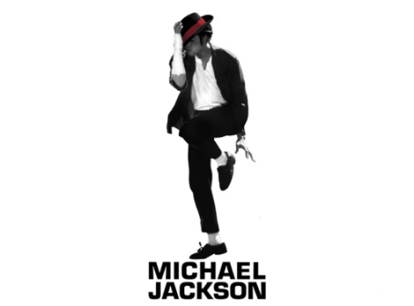

Correct order: 1 _**D**___ 2 __**A**__ 3 __**G**__ 4 ___E_ 5 __**C**__ 6 __F__ 7 ___B_

1. Michael began his musical career at the age of 5 as the lead singer of The Jackson 5 family group in 1964. The Jackson 5 recorded 14 albums.
2. On June 25th, 2009, Michael Jackson suffered a cardiac arrest in his Los Angeles home. They immediately took him to hospital, but he died later that morning. He was 50 years old at the time of his death.
3. In 1994, Michael married his first wife, Lisa Marie Presley, daughter of Elvis Presley. They divorced in 1996.
4. **Michael Jackson was born on the 29th of August, 1958, in Gary, Indiana. He was the 7th of nine children. His brothers’ names are Sigmund "Jackie," Toriano "Tito," Jermaine, Marlon, Steven "Randy," and his sisters’ names are Rebbie, Janet and La-Toya.**
5. In 1983, Michael performed his famous dance move called the Moonwalk for the first time. ‘‘Bad,’’ ‘‘Dangerous,’’ ‘’History,’’ ‘’Invincible,’’ and ‘’One more Chance’’ are some of Michael’s other successful solo albums. He toured the world and took his concerts to many countries.

1. Later that same year, Michael married his second wife, nurse Debbie Rowe. Their first child, Prince Michael Joseph Jackson, was born in 1997. Their daughter, Paris Michael Katherine Jackson, was born on April 3rd, 1998. A year after that, Michael and Debbie divorced.
2. In 1977, Michael made his first film, starring in the musical The Wiz. His first solo album was *Off the Wall*. It was a big success around the world. Jackson’s 1982 album *Thriller* was the world's best-selling album of all time.

**PART B. Read the text again, and fill in the blanks according to the information given in the text.**

* Michael Jackson was born in Gary, Indiana, in 1958. He had (1)___6 BROTHERS AND 3 SİSTERS_____________ .

Their (2)______________________SİGMUND_________________________ and Steven.

He also (3)_____HAD 3___________________ sisters. His (4)____MUSİCAL CAREER________________ started when (5)______5 YEARS__________________________ old. The Jackson 5 was a (6)__FAMILY_GROUP_________________, and Michael was (7)___THE LEAD SİNGER____________ of the group.

They made (8) _____5 RECORDED 15 ALBUMS______________________.

* Michael (9)________the THE MUSICAL THE WİZ_____________________film in 1977. His first solo album was very successful (10)_____AROUND THE WORLD_________________. He made the best-selling album of all time, *Thriller* (11)___JACKSON’S_____1982 ALBUM _____________. ‘’Bad’’ and ‘’Dangerous’’ are just two of Michael’s other successful (12)_____SOLO ALBUMS________________.

* Lisa Marie Presley was Michael’s (13)____FİRST___WİFE________________. She was (14)___________________DAUGHTER_______________ of Elvis Presley. Debbie Rowe, his second wife, (15)__NURSE DEBBIE ROWE________________. The couple had (16)______DAUGHTER__________, a boy and a girl. Michael and Debbie (17)___DIVORCED____________ a year after (18)___ , Paris Michael Katherine Jackson,_____________________ birth.

On June 25th, 2009, Michael Jackson died in (19)____HOME ______________in Los Angeles because (20)________________ Michael Jackson suffered a cardiac arrest ______________________________.